Software Requirements Specification

August 15, 2018

Medicine Shop Software

Subham Dhal

Tanmay Kumar Bisoi

Atul Kumar Agrawal

Submitted in partial fulfillment

Of the requirements of

CS 310 Software Engineering

# Table of Contents

Table of Contents i

1.0. Introduction 1

1.1. Project Description 1

1.2. List of Actors 1

1.3. Scope of Projects 2

1.4. References 2

2.0. Overall Description 4

2.1 Functional Requirements 5

2.1.1 Use Case 5s

2.1.2 Data Flow Diagrams(DFD 0)

2.1.3 Data Flow Diagrams(DFD 1)

2.1.4 Work Breakdown Structure

2.1.5 Entity Relationship Mode

2.2 Non-Functional Requirements 15

2.2.1 System Requirements

2.2.2 Performance Requirements

2.2.3 Security Requirments

2.2.4 Database Requirments

2.2.5 Safety Requirments

1. **Introduction**

It is an application to develop software for medicine shop.This is mainly used for medical stores to maintain the details .

* 1. **Project Description**

Medicine Inventory cum store inventory system to display relevant information about details of products and retail options for the vendor.

**1.2 List of Actors**

**System Administrator, Retailer, Inventory Manager, Customer**

**1.3 Scope of Projects**

To deliver a quick and efficient method to improve retail mechanism along with a hassle free management cum inventory system.

To improve the accessibility of the product and the quantitive management and stock handling thus improving the efficiency in time consumption for the retailer and the customer.

**1.4 References**

IEEE. IEEE Std 830-1998 IEEE Recommended Practice for Software Requirements Specifications*.* IEEE Computer Society, 1998.

**2. Overall Description**

**2.1Functional Requirements**

**2.1.1Use Case**

#### Search Medicine

System Administrator

Search Medicine

**Brief Description**

The administrator accesses the searches for a medicine and prepares the bill and/or maintains stock inventory.

**Initial Step-By-Step Description**

Before this use case can be initiated, the administrator has already accessed the Medicine Administrative page.

1. The administrator chooses to search by medicine name, category, or keyword.
2. The system displays the choices to the administrator.
3. The administrator selects the item desired.
4. The system presents the details like expiry date, cost, manufacturer, supplier and contents.
5. The administrator chooses the item and makes modifications as per the requirement.
6. The system makes the requested changes which can be used by the retailer as and when required.

**2.1.2 Data Flow Diagram (DFD 0):-**

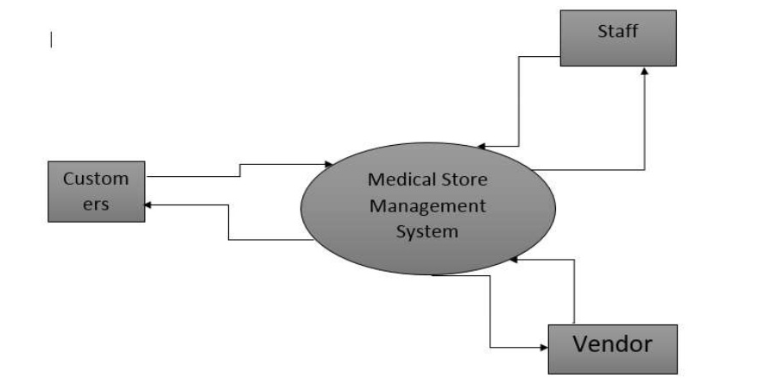

**2.1.3 Data Flow Diagram(DFD 1):-**

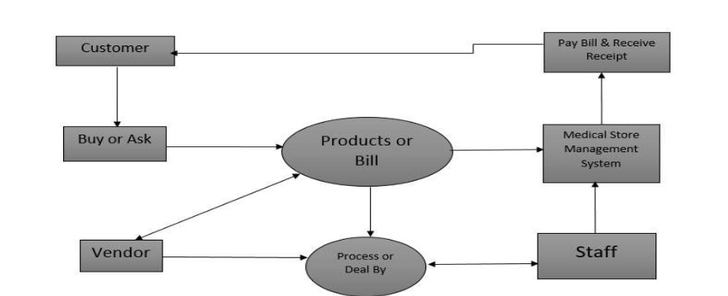

**2.1.4 Entity Relationship Diagrams:-**

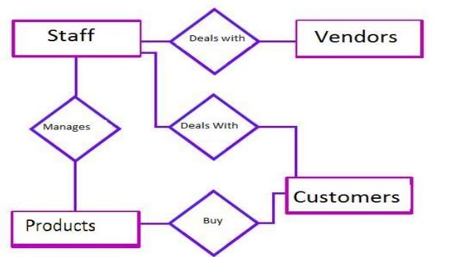

**2.1.5 WORK BREAKDOWN STRUCTURE:-**

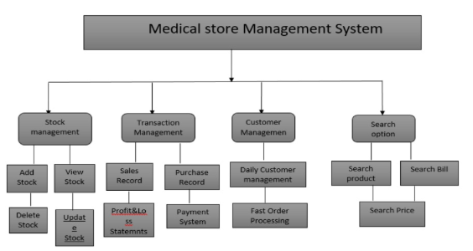

**Admin Login Credentials**

|  |  |  |
| --- | --- | --- |
| **Data Item** | **Type** | **Description** |
| Admin Name | Text | Name of Administrator |
| Login Id | Text | Login details |
| Password | Pointer | Password |

**Retailer Data Entity**

|  |  |  |  |
| --- | --- | --- | --- |
| **Data Item** | **Type** | **Description** | **Comment** |
| Name | Text | Name of Retailer |  |
| Retailer Id | Integer | ID number | Used as key in Database |
| Email Address | Text | Internet address |  |
| Address of correspondence | Pointer | Home Address |  |
| Highest Qualification | Integer | Educational Qualifications |  |
| Phone number | Integer | Mobile number |  |
| Specialty | Category | Area of expertise | May be several |

**2.2 Non Functional Requirements**

**2.2.1 System Requirements**

1. Processor : -intelo i7 8th gen
2. RAM : 512 MB RAM
3. Monitor: 15’’ color monitor
4. Processor Speed:-1.7 GHZ
5. Hard Disk:-1.44 MB FDD
6. CD Drive:-52-X CD ROM
7. Keyboard:-Mercury 110 Keys
8. Mouse:Logitech Mouse

**2.2.2 Performance Requirements**

1. The physician software should be able to support at least three simultaneous users.
2. 95% of the transactions shall be processed in less than one second.
3. Data should be secured and backed up every quarter hour.

**2.2.3 Security Requirments**

1. System will use secure database.
2. Staff can just see the products and mark their attendance.They can not edit or modify anything except their personal information.
3. Proper user authentication will be provided.

**2.2.4 Database Requirements**

**2.2.5 Safety Requirements**